**Modernizing IVR Systems: From Legacy to Conversational AI**

# 1.Legacy IVR Architecture

Legacy IVR (Interactive Voice Response) systems are traditionally built on VoiceXML (VXML) platforms and rely on telephony infrastructure such as PSTN, SIP trunks, and Session Border Controllers. At the core, they consist of an IVR call control/voice browser, a media server for prompts, and integration with ACD/PBX systems for call routing. The application tier connects to ASR/TTS engines for speech interaction, while enterprise systems like CRM and databases handle customer data and transactions.

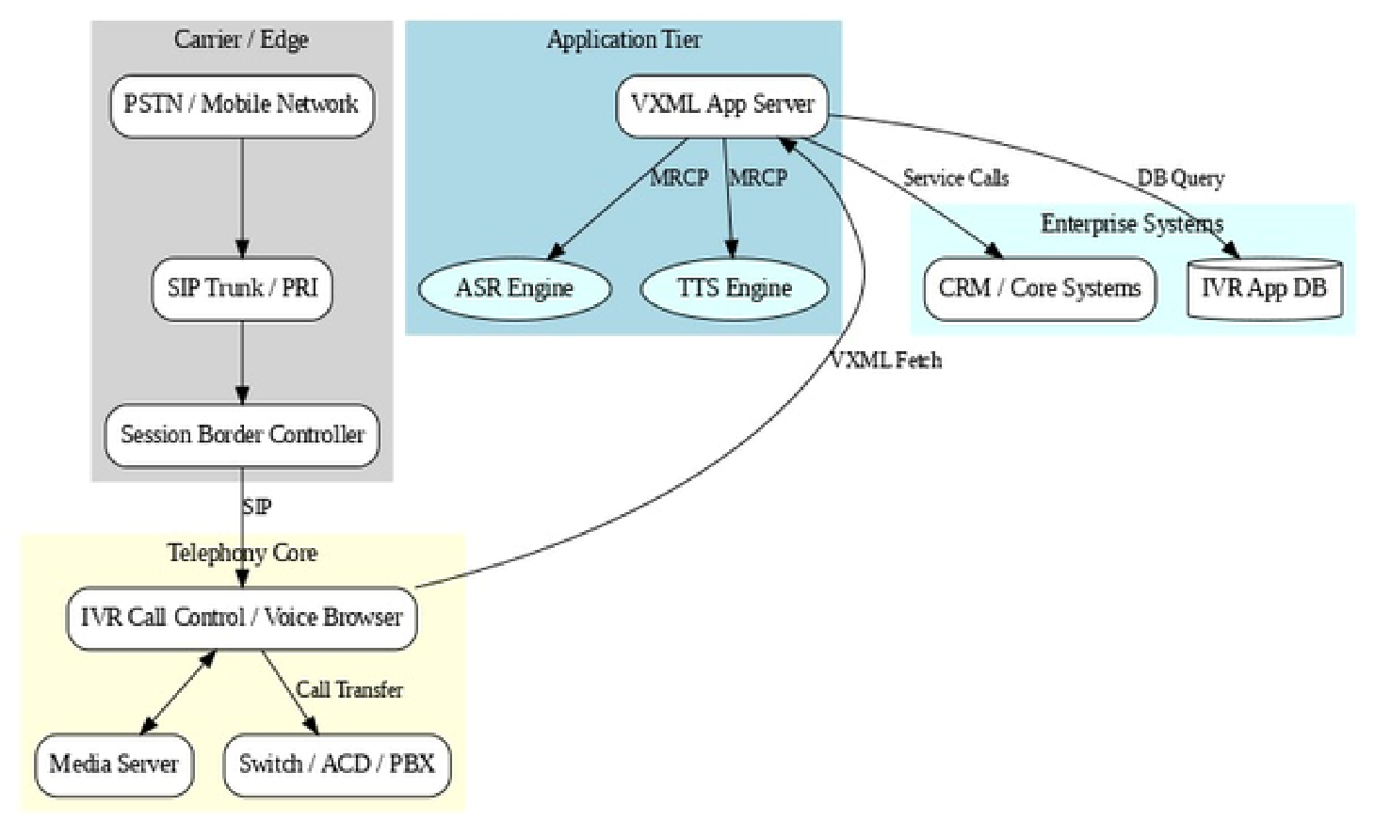

# 2. Limitations of Legacy IVR

While effective in their time, legacy IVR systems face significant challenges:

**Rigid Menu Navigation –** Users must follow strict “press 1, press 2” paths, leading to poor customer experience.

**Limited Natural Language Support** – Dependence on pre-built grammars restricts conversational flexibility.

**High Maintenance Costs** – Frequent updates to VXML scripts and integrations require skilled resources.

**Siloed Architecture** – Limited scalability and difficulty in integrating with cloud services or AI-driven platforms.

**Minimal Analytics** – Traditional reporting captures call events but lacks deep insights into customer intent.

# 3. Transition to Modern Conversational IVR

The modernization project aims to overcome these limitations by extending existing VXML assets and integrating them with Conversational AI platforms such as ACS (Conversational AI Service) and BAP (Bot/AI Platform). This allows legacy IVRs to evolve into AI-driven, cloud-based systems without a complete overhaul.

**4. Key improvements include:**

**Natural Conversations** – Use of NLU (Natural Language Understanding) with ASR and TTS engines enables customers to speak freely instead of following rigid menus.

**Cloud-Native Deployment** – Cloud IVR platforms provide scalability, flexibility, and reduced infrastructure costs.

**Seamless Integration** – APIs and webhooks connect IVR flows to AI bots, CRM, and customer data in real time.

**Analytics & Monitoring** – Advanced AI-driven insights allow continuous improvement of call flows and customer journeys.

**Reuse of Legacy Assets** – Existing VXML scripts are extended, minimizing rework and protecting past investments.

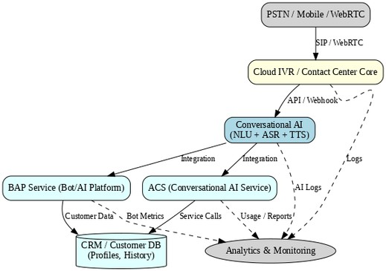

# 5. Modern IVR Architecture

The modern architecture replaces traditional voice browsers with a Cloud IVR core that integrates directly with Conversational AI services. PSTN/Mobile/WebRTC calls are routed into the cloud environment, where AI engines (NLU + ASR + TTS) handle natural interactions. The ACS provides conversational services, while the BAP platform manages bots and dialog workflows. These connect to CRM/Customer DBs for personalized experiences and to Analytics & Monitoring systems for real-time usage insights and AI performance tracking.

In essence, the modern IVR architecture transforms call handling from a menu-driven telephony system into a customer-centric conversational experience, enabling enterprises to improve usability, reduce costs, and future-proof their customer engagement systems.